[Project Address]
Proposed Multi Dwelling Development
[Client]

17 June 2026

[GIWREF]
REV A
giw.com.au
285 Lennox Street
Richmond VIC 3121
+61 3 9044 5111
GIW Environmental Solutions Pty Ltd

Limitations
This Report has been prepared by GIW Environmental Solutions Pty Ltd for the sole use of [Client].It must be presented in full and used only for the project-specific purposes outlined in the Agreement.
Any third-party reliance on this Report is entirely at that party's own risk. GIW Environmental Solutions Pty Ltd makes no warranty or guarantee to third parties and accepts no liability for any third-party use or reliance.
Publication of this Report must comply with the Planning and Environment Act 1987 and Freedom of Information Act 1982. GIW requires formal notification from the Responsible Authority prior to any public release. This Report must be removed from the public domain immediately following the public consultation period.

Copyright
The concepts and information in this Report are the property of GIW Environmental Solutions Pty Ltd. Use or copying of this Report, in whole or in part, without written permission constitutes copyright infringement. Information must not be assigned to a third party without prior consent of the author.

Revision History
Revision | Date | Author | Approved | Comments
A | [Date] | XX | IB | Draft

Report Prepared by:  Project Consultant  Firstname Lastname  ESD Consultant  B.Sc. (Science, Business and Innovation)  M.Sc. (Sustainable Development) |   Report Approved by:  Project Team Leader  Ines Buskermolen  Associate Director  B.Sc. (Science, Business and Innovation)  M.Sc. (Sustainable Development)

Contents
Limitations 2
Copyright 2
Revision History 2
Contents 3
Introduction 4
Project Information 4
Statutory Requirements 5
Built Environment Sustainability Scorecard (BESS) 5
Responsibilities & Implementation 6
Sources of Information 6
Key ESD Initiatives 7
Building Performance Summary 8
ESD Assessment 9
Management 9
Integrated Water Management 10
Operational Energy 12
Indoor Environment Quality 14
Transport 16
Materials 18
Waste & Resource Recovery 19
Urban Ecology 20
Innovation 22
Appendix A – WSUD Response 23
Appendix X – Preliminary Energy Rating Results & Certificates. 29
Appendix X – Renewable Energy 30
Appendix X – Daylight Modelling 31
Appendix X – Natural Ventilation 34
Appendix X – BESS Assessment 35

Introduction

Project Information
The proposed development at [Project Address] will include [XX] apartments constructed over [XX] levels plus Choose an item. and will consist of the following:
- [XX] x 1 bedroom apartments
- [XX] x 2 bedroom apartments
- [XX] x 3 bedroom apartments
The site has an approximate surface area of [XX]m² and is currently the location of a XX. Distance from the site to Melbourne CBD is approximately [XX]km.
ADD 9.7hx17.4w
Figure 1 - Pre-existing sites at [Project Address].

Statutory Requirements
This SMP has been prepared in response to the following Planning Scheme requirements:
Planning Scheme Clause | Application Requirement | Example Tools
Choose an item | Sustainability Management Plan (SMP) | BESS  Green Star  MUSIC  STORM / Blue Factor
Choose an item. | Meet the current best practice performance objectives for stormwater quality as contained in the Urban Stormwater - Best Practice Environmental Management Guidelines (Victorian Stormwater Committee, 1999). | MUSIC  STORM / Blue Factor
Choose an item Planning Scheme - Clause 15.01-2S | N/A | N/A

Built Environment Sustainability Scorecard (BESS)
The development has been assessed using the Built Environment Sustainability Scorecard (BESS).
 |  |  | 
Management | Integrated Water Management (IWM) | Operational Energy | Indoor Environmental Quality (IEQ)
 |  |  | 
Transport | Waste & Resource Recovery | Urban Ecology | Innovation
Figure 2 - BESS Environmental Categories (www.bess.net.au)

Responsibilities & Implementation
The [Client] shall bear sole responsibility for the implementation of all requirements set forth in this Report throughout the design and development phases. In the event of a sale or transfer of the subject property, such responsibility shall pass in its entirety to the incoming proprietor by operation of the transfer. Upon engagement of a builder or head contractor, responsibility for implementation shall vest in that party for the duration of the construction phase. Following the grant of an occupancy certificate, the Owners Corporation and all individual lot and unit owners and tenants shall be jointly and severally responsible for the proper operation and use of all installed equipment and systems in strict accordance with the Building User's Guide.

Sources of Information
The following ‘Sources of Information’ have been used to guide the design solutions:
- [Architect] – Project No. XXX – Drawing No. XXX
- Municipal Association of Victoria - SDAPP Explained; Building Design for a Sustainable Future
- Built Environment Sustainability Scorecard (BESS)
- CSIRO 1999, Urban Stormwater – Best Practise Environmental Management Guidelines

Key ESD Initiatives
 | The project achieves a total BESS score of [XX]% with no mandatory category (IEQ, Operational Energy, IWM) below 50%.
 | - Water efficient fittings and fixtures are applied throughout.
 | - A [XXX] litre rainwater tank will harvest rainwater from XXX.
 | - A Blue Factor rating of 100% is achieved
 | - [XX]
 | - The development is to achieve a [7.0] Star NatHERS Energy Rating.
 | - The development is to utilise Choose an item..
 | - A [XX]kW Solar PV system is to be located on the roof of the development.
 | - The majority of the development meets BESS IEQ requirements.
 | - [XX% of the development’s apartments are naturally cross-ventilated.
 | - The development complies with the BESS Choose an item. method for Daylight.
 | - [XX] bicycle spaces are to be provided for residents.
 | - [XX] bicycle spaces are to be provided for residential visitors.
 | - Choose an item.
 | - At least 80% of the waste generated during construction and demolition has been diverted from landfill
 | - Separate general, recycling, glass and organic waste storage will be provided at XXX
 | - [XX]m2 of communal space will be provided at XXX.
 | - The total area of vegetation is [XX]% of the site area
 | - [XX]m2 of communal food production area will be provided.


Building Performance Summary
[SMP Visualisation. Copy from C2 to U25 from excel sheet. Paste as image]

ESD Assessment

Management
Council ESD objectives:
- To encourage a holistic and integrated design and construction process and ongoing high performance.
Council Best Practice Standard
Criteria |  | Construction and Building Management Actions
Pre-Application Meeting | To ensure appropriate sustainable design principles and strategies are considered from the preliminary design stage of each development. | Choose an item.
Metering | To provide building users with information that allows monitoring of energy and water consumption | Electricity, cold water, hot water or gas metering is to be provided to each individual apartment.  Lighting and general power to common areas is to be separately metered to quantify energy used for common areas spaces.
Building User’s Guide | To encourage and recognise initiatives that will help building users to use the building more efficiently. | A Building User’s Guide will be provided to all occupants explaining the main sustainable design initiatives, systems and processes that building users will interact with.

Integrated Water Management
Council ESD objectives:
- To reduce total operating potable water.
- To encourage the appropriate use of alternative water sources (including greywater, rainwater and stormwater).
- To incorporate best practice water sensitive urban design to improve the quality of stormwater runoff and reduce impacts on water systems and water bodies.
Council Best Practice Standard
Criteria |  | Development Provision
Stormwater Treatment | To minimise negative environmental impacts of stormwater runoff and maximise onsite re-use of stormwater. | A Blue Factor rating of 100% is achieved via the following:  - Rainwater is to be collected from XX and directed into the [XX] litre rainwater tank. XX WC’s are to be connected to the rainwater tank.  - Rainwater is to be collected from XX and directed into a ≥XXm2, minimum 1,150mm deep raingarden with 300mm of extended detention.  Refer Appendix A – WSUD Response
Potable Water Reduction | To reduce total potable water use due through the use of efficient fixtures, appliances, and the use of rainwater. | WELS [4] Star - Toilets WELS [5] Star -Taps WELS [4] Star -Showerhead WELS [5] Star -Dishwasher    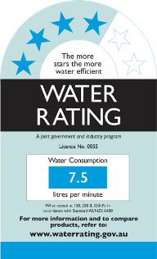 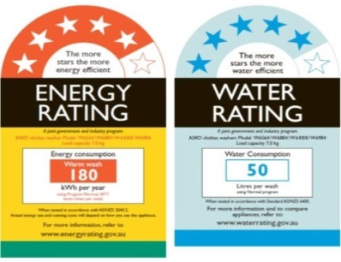
Rainwater Collection & Reuse |  | A [XX] litre rainwater tank will harvest rainwater from XXX. This tank will be connected to XXX.  Stormwater drainage mechanism is to be determined by the hydraulics services engineer at the design development phase.  Refer Appendix A – WSUD Response.
Landscape Irrigation | To ensure the efficient use of water and to reduce total operating potable water use through encouraging water efficient landscape design. | [XX]
Building System Water Use Reduction | Ensure the efficient use of water, to reduce total operating potable water use and to encourage the appropriate use of alternative water sources for cooling and fire testing systems. | >80% of fire test water (e.g. hydrant pump test water or SCV annubar test) is to be reused on site, either within the fire test system itself, irrigation, toilet flushing, or other non-potable uses. Final coordination and confirmation of these options will occur with the fire engineer at a later stage.  The proposed development is to incorporate air-cooled HVAC systems for both the residential and non-residential areas within the development.

Operational Energy
Council ESD objectives:
- To reduce both energy use and energy peak demand through design measures.
Council Best Practice Standard
Criteria |  | Development Provision
Thermal Performance Rating - Residential | To reduce energy needed to achieve thermal comfort in summer and winter - improving comfort, reducing greenhouse gas emissions, energy consumption, and maintenance costs. | The National Construction Code (NCC) Class 2 – Sole Occupancy Unit(s) residential building component is to be designed in accordance with NCC Section J (2022) NatHERS requirements. The residential units must achieve an average [XX] Star rating, with no unit achieving below 6.0 Stars and no units exceeding the maximum allowed cooling load of Choose an item. (BADS).  Refer Appendix X – Preliminary Energy Rating Results & Certificates.
Electrification | To support the transition to renewable energy sources. | The development will be all-electric with no gas connection.
HVAC System | To ensure the efficient use of energy and to reduce consumption of electricity. | Inverter split systems are to be installed and sized to maintain conditions of the habitable rooms of each apartment. Heating and cooling systems are to have an Energy Efficiency Ratios (EER) not less than 85% of the EER of the most efficient equivalent unit available (type & capacity).
Hot Water System | To ensure the efficient use of energy and to reduce consumption and greenhouse emissions from water heating. | The development is to utilise [XX]
Car Park Ventilation | To ensure the efficient use of energy, reduce total operating greenhouse gas emissions and to reduce energy peak demand. | Carpark ventilation fans are driven by a VSD motor connected to CO sensors within the carpark.  The mechanical services engineer is responsible for the design and specification of the system. The contractor is to procure and install the specified system.  Maintenance requirements of the CO sensor system are to be included in the O&M manual.
Clothes Drying | Ensure the efficient use of energy and to reduce energy consumption and greenhouse emissions associated with clothes drying | Choose an item.
Internal Lighting - Residential | To ensure the efficient use of energy, to reduce energy consumption, greenhouse emissions associated with artificial lighting, and to reduce energy peak demand. | The maximum illumination power density (W/sqm) is at least 20% lower than NCC 2022 requirements.  Lighting power density shall be as follows:  - Dwellings: No greater than average 4W/m2  - POS: No greater than average 3.2W/m2  - Back of house and indoor car parks: No greater than average 1.6W/m2  All common area, external and carpark lighting is to be controlled with daylight, motion sensors or timers (whichever is deemed appropriate).
Renewable Energy Systems - Solar | To encourage on-site renewable energy generation and reduce greenhouse emissions. | A [XX]kW Solar PV system is to be located on the roof of the proposed. The system is expected to generate approximately [XX]kWh and will be connected to common area lighting and power.  Refer Appendix X – Renewable Energy

Indoor Environment Quality
Council ESD objectives:
- To achieve a healthy indoor environment quality for the wellbeing of building occupants.
- To provide a naturally comfortable indoor environment will lower the need for building services, such as artificial lighting, mechanical ventilation and cooling and heating devices.
Council Best Practice Standard
Criteria |  | Development Provision
Daylight Access - Residential | To provide a high level of amenity and energy efficiency through design for natural light. | Daylight modelling has been conducted for a representative sample of apartments. The summary result is as follows:  % of living floor area above DF 1.0 % of bedroom floor area above DF 0.5  [XX]% of Living areas [XX]% of Bedrooms  Refer Appendix X – Daylight Modelling.  Or  The majority of the development complies with the Deemed-to-Satisfy method for IEQ prescribed by BESS.  - All North, West and East oriented living areas and bedrooms are less than 8m deep. All south facing apartments is less than 5m in depth.  - All living areas and bedrooms have a floor-to-ceiling height of 2.70m.  - All glazing to living areas achieves at least 60% visible light transmittance.  - All living areas have an external facing window.  - All living areas and bedroom areas comply with the requirements of the building separation tables.
Winter Sunlight | To provide a high level of amenity and reduce need for artificial heating in winter. | [XX% (XX out of XX)] of apartments achieve at least 3 hours of sunlight.
Minimal Internal Bedrooms | 90% of bedrooms have an external window. | NIL internal bedrooms.
Effective Natural Ventilation | To provide fresh air and passive cooling opportunities. | [XX% (XX out of XX)] of the development’s apartments are naturally cross-ventilated. Apartments are provided with windows on opposite or adjacent facades or are effective single sided ventilated.  Refer Appendix X – Effective Natural Ventilation
Thermal Comfort | To provide comfortable indoor spaces and reduce energy needed for heating and cooling. | The development is provided with a comprehensive shading strategy:  - XXX.  - XXX.

Transport
Council ESD objectives:
- To promote the use of walking, cycling and public transport, in that order; and minimise car dependency.
- To promote the use of low emissions vehicle technologies and supporting infrastructure.
Council Best Practice Standard
Criteria |  | Development Provision
Bicycle Parking – Residential & Residential Visitors | To encourage and recognise initiatives that facilitate cycling. | [XX] bicycle spaces are to be provided for residents. This will provide a ratio of approximately 1 resident bicycle space for every apartment.  [XX] bicycle spaces are to be provided for residential visitors. This will provide a ratio of approximately 1 visitor bicycle space for every X apartments.
Electric Vehicle Infrastructure | To minimise car dependency and to ensure that the built environment is designed to promote the use of public transport, walking and cycling. | No car parking spaces are specifically intended for electric vehicles.  Future infrastructure for electrical charging points is incorporated in the services design for Choose an item.
Car Share Scheme | To minimise car dependency and to ensure that the built environment is designed to promote the use of public transport, walking and cycling. | The proposed development will incorporate a dedicated car parking space for car sharing.
Motorbikes / Mopeds | To minimise car dependency and to ensure that the built environment is designed to promote the use of public transport, walking and cycling. | The proposed development will incorporate min. [XX] motorbike / moped spaces in the basement carpark. This represents ≥5% of the total carparking.

Materials
ESD objectives:
- Use of low embodied energy materials.
- Encourage use of recycled and reusable materials in building construction and undertake adaptive reuse of buildings, where practical.
Council Best Practice Standard
Criteria |  | Development Provision
Embodied Energy | Limited use of high embodied energy materials | The design will seek to limit the use of high embodied energy metal finishes.  Concrete mixes used within the project will seek to reduce Portland cement and aggregate content where deemed appropriate by the structural engineer.
Structural and Reinforcing Steel | Commitment to source structural and reinforcing steel from a responsible steel maker | The building’s steel (by mass) is to be sourced from a Responsible Steel Maker with:  - a currently valid and certified ISO 14001 Environmental Management System (EMS) in place; or  - is a member of the World Steel Association's (WSA) Climate Action Programme (CAP)
Sustainable Timber | Commitment to source timber from sustainably managed source | Where timber is to be used, such timbers are to accord with the GBCA’s ‘Essential’ criteria for forest certification (FSC or PEFC). Alternatively, recycled timber will be used.
PVC | Commitment to source best practice PVC products | Permanent formwork, pipes, flooring, blinds and cables in the project will seek to comply with the following:  - Meet the GBCA’s Best Practice Guidelines for PVC. or;  - The supplier holds a valid ISO140001 certification.
Sustainable Products | Commitment to source products that meet the transparency and sustainability requirements | The project will incorporate products that meet the transparency and sustainability requirements where deemed appropriate. This includes the following: reused products, recycled content products, environmental product declarations, third party certified and stewardship programs.

Waste & Resource Recovery
Council ESD objectives:
- To promote waste avoidance, reuse and recycling during the design, construction and operation stages of development.
- To encourage use of durable and reuseable building materials.
- To ensure sufficient space is allocated for future change in waste management needs, including (where possible) composting and green waste facilities.
Council Best Practice Standard
Criteria |  | Development Provision
Building Re-use | To ensure waste avoidance, reuse and recycling during the design. | Choose an item.
Construction and Demolition Waste | To reduce construction waste going to landfill | At least 80% of the waste generated during construction and demolition has been diverted from landfill.
Food & Garden Waste | To ensure waste avoidance, reuse and recycling during the operational life of the building. | Green waste storage is provided in the XXX.
Convenience of Recycling | To ensure waste avoidance, reuse and recycling during the operational life of the building. | Separate general, recycling, glass and organic waste storage will be provided at XXX.  Each tenancy is to be provided with separate general, recycling and food and organics waste bins. This requirement is to be included in the owner’s corporation rules or lease agreement.  Kitchen joinery for the residential units is to provide appropriate spatial allowance for food and organics, general and recycling waste collection.

Urban Ecology
Council ESD objectives:
- To protect and enhance biodiversity.
- To reduce urban heat island effects.
- To encourage the provision of space for productive gardens, particularly in larger residential developments.
Council Best Practice Standard
Criteria |  | Development Provision
Communal Space | To encourage and recognise initiatives that facilitate interaction between building occupants. | [XX]m² of communal space will be provided at XXX. Communal space will include the following amenities: XXX, XXX.
Vegetation | To encourage and recognise the use of vegetation and landscaping within and around developments. | Planter boxes are to be located XXX.  Landscaped area is to be located XXX.  The total area of vegetation is [XX]% of the site area.
Green Walls / Roof | To encourage the appropriate use of green roofs, walls and facades to mitigate the impact of the urban heat island effect. | The proposed development will incorporate a green wall / roof at XX.
Private Open Space - Balcony / Courtyard Ecology | To encourage plants in a healthy ecological context to be grown on balconies and in courtyards. | All balconies or private open space have been provided with a tap and floor waste allowing residents to cultivate their own gardens.
Food Production - Residential | To encourage the production of fresh food on-site. | [XX]m2 of communal food production area will be provided at XX.
Heat Island Effect | To reduce the contribution of the project site to the ‘heat island effect | Roofs are to have a three-year SRI of minimum 60.  Unshaded hard-scaping elements are to have a three-year SRI of minimum 40.

Innovation
Council ESD objectives:
- To encourage innovative technology, design and processes in all development, which positively influence the sustainability of buildings.
Council Best Practice Standard
Criteria |  | Development Provision
Materials Exchange | To minimise waste reduction through reuse, recycle and community engagement. | The development will implement a materials exchange initiative that facilitates the sharing and recycling of furniture, tools, and other resources among community members.
Life Cycle Assessment | To reduce carbon emission and resource consumption. | A life cycle assessment is to be undertaken during the Design Development phase. The embodied carbon of the development will be benchmarked against a standard practice building to determine the percentage reduction achieved. The life cycle results will be used to inform material selection, construction practices and end of life treatment.
Carbon Neutral Ready Development | To reduce environmental impact and contribute to a sustainable future by minimizing carbon emissions. | The proposed development will be established with a carbon neutral power agreement between developer, owner’s corporation, and electrical retailer to provide GreenPower for all energy consumed by building (including communal areas, apartments and retail tenancy). It is the intent to maintain this agreement for a minimum of 10 years.
ESD Checkpoint during Construction Phase | To ensure that all ESD items are suitably installed and incorporated during construction. | An ESD professional will be engaged throughout the design and construction process. The ESD professional will perform a minimum of 2 site inspections during the construction phase to ensure suitable implementation of the ESD initiatives. Any deficiencies compared to the endorsed SMP will be escalated to the project manager and resolved.  The checkpoint assessments will be undertaken at two stages as follows:  - Site Inspection 1: Prior to installation of internal linings.  - Site inspection 2: At the time of project completion.

Appendix A – WSUD Response
Site layout Plan
The following architectural mark-up illustrates the rainwater collection and impervious areas of the proposed development site.
ADD
Figure 3- Mark-up of water catchment and impervious areas

Blue Factor Rating
A Blue Factor rating of ≥100% can be achieved by implementing the following initiatives:
- Rainwater is to be collected from XX and directed into the [XX] litre rainwater tank. XX WC’s are to be connected to the rainwater tank.
- Rainwater is to be collected from XX and directed into a ≥XXm2, minimum 1,150mm deep raingarden with 300mm of extended detention.

Blue Factor was developed by Microburst Software with support from DEECA. as a method of simplifying the analysis of stormwater treatment methods. The Blue Factor Calculator displays the amount of treatment that is required to meet best practice targets, using WSUD treatment measures.
The best practice standards have been set out in the Urban Stormwater Best Practice Environmental Management Guidelines (Victoria Stormwater Committee, 1999) for reduction in total suspended solids (TSS), total phosphorus (TP) and total nitrogen (TN) loads.
Note: Blue Factor provides a ‘deemed to comply’ pathway for low-risk developments. Under this pathway, a project meets the minimum planning requirement for total nitrogen but may not achieve all on-site stormwater flow management objectives. A development is considered ‘deemed to comply’ when it attains a Blue Factor rating of ≥100%.

WSUD Strategy
The development will include the provision of a [XX] litre rainwater tank and associated pump in the basement garage. The rainwater tank is to be connected to XX WC’s and in-ground drip irrigation system.
 | 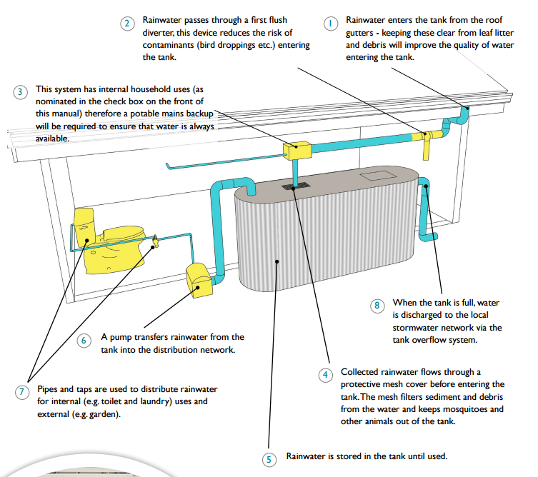
Figure 4 – Location Rainwater Tank | Figure 5 – Cross-section Tank (City of Port Phillip)

Furthermore, a ≥XXm², minimum 1,150mm deep raingarden with 300mm of extended detention is to be provided. Rainwater collected from XXX is to be directed into the raingarden for treatment prior to discharge into the stormwater system.
 | 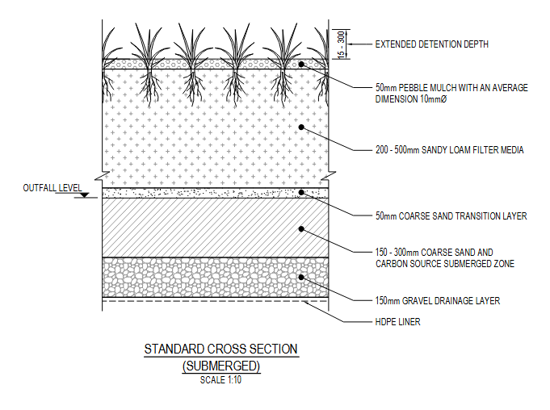
Figure 6 – Location Raingarden | Figure 7 – Cross-section Raingarden (City of Moreland)

Rainwater Reuse

Site Management Statement
Prevention of litter, sediments and pollution entering the stormwater system in the construction phase is to be addressed through introduction of the following initiatives:
- Buffer strips to pervert stormwater runoff.
- Gravel sausage filters at stormwater inlets to prevent silt, mud or any other site contaminant from entering the stormwater system.
- Silt fences under grates at surface entry inlets to prevent sediment from entering the stormwater system.
- Temporary rumble grids to vibrate mud and dirt off vehicles prior to leaving the site.
- The site is to be kept clean from any loose rubbish or rubble.
- Introduction of offsite construction for building elements where deemed appropriate.
The builder is to include these initiatives in the construction management plan and address these during site induction of relevant contractors.

Maintenance Program
The following maintenance requirements are to be programmed to ensure the rainwater tank operates effectively:
Item | Description | Maintenance Interval
Gutters and downpipes | Eave and box gutters are to be inspected and cleaned to prevent large debris from being washed into rainwater tank. | 3 monthly
First flush system (as applicable) | Inspect and clean excess sediment from diverter chamber to prevent blockages. | 3 monthly
Tank contents | Siphon the tank to inspect contents. If sludge is present, a plumber will be required to drain tank contents and clean the tank. | 2 to 3 years
Tank structure | Inspect tank externally for leaks | Yearly
Pump system | Inspect pump wiring, plumbing and check for smooth operation. | 6 monthly
Plumbing | Plumbing and fixtures connected to the rainwater tank is to be inspected for leaks. | Yearly

The following maintenance requirements are to be programmed to ensure the raingarden operates effectively:
Item | Description | Maintenance Interval
Kerbing and paved area | Remove rubbish, leaves and other debris from the surrounding drainage area. | 3 monthly
Ponding area | Clear inflow points of built-up sediment, rubbish and leaves.  Check for erosion or gouging – repair if necessary. | 3 monthly
Mulch layer (bark, pebbles, etc.) | Remove rubbish, leaves and other debris.  After storm events mulch may need to be redistributed or added around inflow points. | 3 monthly
Plants | Water establishing plants monthly during extended dry periods.  Check plant health and replace dead plants as necessary.  Use native species to suit garden conditions (e.g. full sun or shaded).  Remove weeds – do not use herbicides, pesticides and fertilisers as these chemicals will pollute the stormwater runoff. | 3 monthly
Rain garden soil mix | Check soil level is below surrounding hard surface level and overflow grate. Use drainage test to check soil is free draining. | Annually
Underdrain system | Use inspection well (if present) to check underdrain is working properly.  Check rain garden draining freely using drainage test. | Annually

Blue Factor Report

Appendix X – Preliminary Energy Rating Results & Certificates.
The National Construction Code (NCC) Class 2 – Sole Occupancy Unit(s) residential building component is to be designed in accordance with NCC Section J (2022) NatHERS requirements. The residential units must achieve an average [XX] Star rating, with no unit achieving below 6.0 Stars.
Further to this the development will need to comply with the following heating and cooling load limits:
Climate Zone | Heating load limits (MJ/m2) | Cooling load limits (MJ/m2)
21 Melbourne RO | Maximum: 55 | Maximum: 30 (BADS)
60 Tullamarine | Maximum: 103 | Maximum: 22 (BADS)
62 Moorabbin | Maximum: 91 | Maximum: 21 (BADS)
The apartments are currently achieving a X.X Star average. The below sample ratings demonstrate the developments ability to achieve these requirements.

Apartment No. | ACE Total MJ/M2 | ACE Heating MJ/M2 | ACE Cooling MJ/M2 | ACE NCFA | Star Rating
Average
*Apartments are assessed using FirstRate5 v5.5.5

Construction assumptions for preliminary FirstRate5 ratings are listed below. Note, these assumptions are based on the sample of apartments assessed and may vary throughout the development. These assumptions are not to be relied upon for any other purpose beyond Town Planning assessment.

Element | Material | Insulation Value
Floor | Suspended Concrete Slab | RX.X
External Walls | Concrete | RX.X+RFL
External Walls | Lightweight | RX.X
Internal Walls | Concrete | RX.X+RFL
Internal Walls | Plasterboard | RX.X
Roof | Metal Framed Deck | RX.X+RX.X
Fixed Windows | Aluminium framed, Double glazed, Argon filled, Clear | Total System:  - U-Value: XXX  - SHGC: XXX
Sliding Doors | Aluminium framed, Double glazed, Argon filled, Clear | Total System:  - U-Value: XXX  - SHGC: XXX
Awning Windows | Aluminium framed, Double glazed, Argon filled, Clear | Total System:  - U-Value: XXX  - SHGC: XXX

Appendix X – Renewable Energy
ADD
Figure 8 - Location Solar PV System

PVWatts Calculator

Appendix X – Daylight Modelling

Scope of Modelling
We have undertaken daylight modelling for XXX assessing both living and bedroom areas. XXX have been selected with consideration of internal layout, inherent and adjacent building shading features. These apartments reflect a worst-case scenario with all other units anticipated to achieve the BESS performance requirements.
The development has been modelled under an equitable development rights scenario with a similar building to that of the proposed on the east, west and south boundaries.

Methodology
The daylight levels in apartments are benchmarked against the best practice requirements as set out under the Built Environment Sustainability Scorecard (BESS) tool: Indoor Environment Quality (IEQ) – Daylight Access Living Areas and Bedrooms. These levels are as follows:
“Dwellings should achieve the following daylight factors (DF)
- 80% of the total number of living rooms achieve a daylight factor greater than 1% to 90% of the floor area of each living area, including kitchens.
- 80% of the total number of bedrooms achieve a daylight factor greater than 0.5% to 90% of the floor area in each room.”
The daylight modelling has been completed using the Radiance software suite, an accurate computing program used to predict light levels in a space prior to construction. Scene geometric data and material properties are interfaced into the Radiance software using Choose an item.
Daylight Factor has been calculated using a CIE uniform cloudy sky.
ADD
Figure 9 – Choose an item. model of proposed and adjacent equitable development right buildings

Modelling Assumptions
The following assumptions have been made with respect to the modelling:
- Modelled window dimensions and shading structures are as depicted on the Architectural drawings.
- The glazing performance used for external windows is as follows:
- Double glazed, low-e, clear window with a total system VLT of 0.61.
- The reflectance of all materials is in accordance with the below:
- Floors: 0.3
- Walls: 0.7
- Ceilings: 0.8
- Transient and unoccupied spaces such as corridors and wardrobes have been excluded from the modelled area.
- The reflectance of external buildings and structures is assumed to be 0.4.

Daylight Results – Numerical
The daylight results for living areas of [Project Address] can be summarised as follows:
Area | Floor Area (m2) | Floor Area above DF1 (m2) | % of floor area above DF1 | Status
The daylight results for bedrooms of [Project Address] can be summarised as follows:
Area | Floor Area (m2) | Floor Area above DF0.5 (m2) | % of floor area above DF0.5 | Status

Daylight Results – Visual
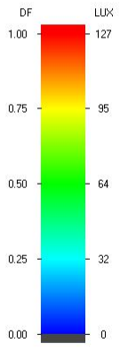
Figure 10 - Daylight Map - XXX

Overall Building Results
Apartment No. | Total Living Areas | Living Areas Compliant | Total Bedrooms | Bedrooms Compliant
Total
Percentage | XX% of Living areas |  | XX% of Bedrooms

Conclusion
The development has been assessed, and it has been determined that all living areas and ≥80% of bedrooms will achieve the daylight factors as prescribed under BESS and therefore the development will meet the BESS IEQ guidelines for daylight.

Appendix X – Natural Ventilation
ADD
Figure 11: Natural cross-ventilated apartment - X floor

ADD
Figure 12: Natural cross-ventilated apartment - X floor

Overall Building Results
Floor Level | Cross-ventilated | Single Sided ventilated | Non-compliant | Total Compliant
G | 1 | 0 | 0 | 1
1 | 2 | 0 | 0 | 2
2 | 4 | 1 | 8 | 5
3 | 4 | 1 | 8 | 5
4 | 4 | 2 | 8 | 6
5 | 1 | 0 | 8 | 1
6 | 1 | 1 | 8 | 2
7 | 3 | 0 | 0 | 3
Total | 20 | 5 | 40 | 25
Percentage of development naturally ventilated
40%

Appendix X – BESS Assessment

